**Table of contents**

**Reading 1 - Introduction and basic neurophysiology** **2**

**Reading 2 - A guided tour of the human brain** **3**

**Reading 3 - Methods of Cognitive Neuroscience with focus on fMRI** **5**

**Reading 4 - Hemispheric Specialization** **7**

**Reading 5 - Sensation and Perception with a focus on audition** **8**

**Reading 6 - Object recognition with a focus on faces and words** **9**

**Reading 7 - Action and the motor system** **10**

**Reading 8 - EEG and ERP with a focus on language** **11**

**Reading 9 - Memory & Emotion** **12**

**Reading 10 - Language** **13**

**Reading 11 - Cognitive Control and Summary** **14**

**Highlights:**

Key words (light green 1)

Experiments (light red 1)

Other relevant stuff (light blue 1)

Perspectivation to other chapters (light yellow 1)   
Perspectivation to our experiment (light magenda 1)

**Description of qualifications:**

In the assessment of the exam performance, emphasis is placed on the extent to which the

student:

- Understands and is able to describe the structure and function of the neuron

- Understands the overall structure of the brain

- Understands the primary neural systems involved in cognitive processes

- Is able to critically evaluate published neuroscientific literature

- Can participate in and critically evaluate data collection procedures

# Reading 1 - Introduction and basic neurophysiology

Literature: Gazzaniga et al p. 1-39

Instead of looking at the bigger picture to what degree of mind is modular, I’ll focus on the miniscule constituent parts of the Neuron, to investigate what makes them tick.

* Nervous system (brain + spinal cord) consists of neurons + glial cells (50/50)
  + Neurons → transmit information throughout the nervous system (at synapses - chemical and electrical signals can be conveyed)
    - structure: cell body, dendrites, axon, axon terminals, myelin (figure 2.3)
    - Grandmother cell (Gnostic units) → known stimulus (fame) - Halle Berry

((Gross ([2002](https://www.ncbi.nlm.nih.gov/pmc/articles/PMC3662881/#B8), p. 512): “*The term “grandmother cell” refers to a neuron that would respond only to a specific, complex, and meaningful stimulus, that is, to a single percept or even a single concept.))*

* + Glial cells → BBB (astrocytes), structural support, speed of information transfer forming myelin (oligodendrocyte), might play a bigger role in neural activity (respond to and release neurotransmitters --> this is still quite uncertain)
    - BBB: Restricts the diﬀusion of microscopic objects (most bacteria) and large hydrophilic molecules in the blood from entering the neural tissue.
* Neuronal signaling → action potential (figure 2.11)
  + if depolarization reaches a threshold = action potential →
* Synapses:
  + Chemical
    - Within a neuron, transferring information involves changes in the electrical state of the neuron as electrical currents ﬂow through the axon
    - Release of neurotransmitters from one neuron to another in the synaptic cleft from vesicles in the post-synaptic cell
    - Neurotransmitters binds with specific receptors embedded in the postsynaptic membrane
    - The neurotransmitter binding induces a change in the receptor, which opens specific ion channels and results in an inﬂux of ions leading to either depolarization (excitation) or hyperpolarization ( inhibition) of the postsynaptic cell = possible new action potential.
  + Electrical
    - passing current directly from one neuron to another via gap junctions
    - (directly connected to cytoplasm of another cell)
* Blood supply
  + Blood flow in the brain couple with increase in neuronal activity (like a muscle a working neuron needs oxygen to perform) → possible to use this as a measure of local changes → haemodynamic response → BOLD → more oxygenated compared to deoxygenated hemoglobin → fMRI

If time allows one could look into some historical figures that give an idea and how we arrived at the brain science we have today

* Franz Joseph Gall -> pheronology -> Seat of the mind (away from Aristotles “the soul sits in the heart”). Focus shifted to the brain.
* Jackson -> Topographic mapping (Seizures in epileptic) -> Stimulate
  + cf. Homunculus and somatosensory cortex
* Brocas and Wernicke’s
  + Brodmann -> Areas do stuff (52) -> Nissl stain -> Cytoarchitecture
  + Intro, gestalt, Thorndike and skinner, Hepp and Miller (fire together – magical number 7)
  + **“small-world architecture”**

-------

ex. What does it mean to have more activity?

* Then go into how it all works.

The small world architecture and relate it to fusiform face area. Modularity.

three main parts of a neuron. dendrite and so on. When neurons transmit information, it means that… There are two ways neurons can communicate information, inhibitory and excitatory.

inhibitory neurotransmitters block receptors on the postsynaptic neuron.

neuron: axon, soma, dendrite

* dendrite connects to presynaptic cells → soma gets depolarized → action potential send down the axon → connecting at a synapse to other dendrites that either hyperpolarize (inhibition) or depolarize (excitation)
* depend on the postsynaptic cells receptors → either they have an influx of ions or efflux of them

--------

# Reading 2 - A guided tour of the human brain

Literature: Gazzaniga et al p. 40-69  
<https://www.youtube.com/watch?v=vHrmiy4W9C0&t=306s>

The brain

* Four lobes, two hemispheres (separated by the interhemispheric fissure - connected by the corpus callosum)
* Gray matter = neuronal cell bodies
* White matter = axons tracts + glial cells
* Gyri = protruding areas on the surface of the cortex
* Sulci + fissures = enfolded regions of the cortex

Evolutionary view of the brain:

* The old brain: The brainstem → medulla, pons + cerebellum and midbrain
  + Respiration, REM sleep + posture/coordinated movements and objects in the periphery
  + Basic survival functions
* Limbic system: amygdala, hypothalamus, hippocampus
  + Emotions, learning, memory
* Cerebral cortex

Why is the brain anatomy relevant?

* The structure implies function, which is what we are investigating
  + **If damage to the same area create similar deficits → evidence for structure-function**
* Connections between areas may be functionally relevant to see interconnections e.g. structures important for language
* Inspiration for development of AI
  + Blood flow → used as measure of local changes in neuronal activity (fMRI - changes in the concentration of oxygenated and deoxygenated blood in the active tissue)

Different parts of the brain responsible for different things

* Fusiform gyrus → faces + places + shapes
* Prefrontal cortex → make decisions + advanced behavior (Phineas Gage)
* Hypothalamus → maintaining the normal state of the body (sends signals about hunger, thirst etc.)
* The basal ganglia → action selection, motor preparation, reward-based learning (EXAMPLE!)
* Cytoarchitectonics (organization of cells to subdivide the cortex) → Brodman division → 52 regions, according to differences in cellular morphology and organization (fusiform gyrus is in Brodman area 37)
* Somatotopy → parts of body linked to the cortex (Homunculus)
* Association cortex → language, abstract thinking, designing (Maserati)
* Limbic system → emotion

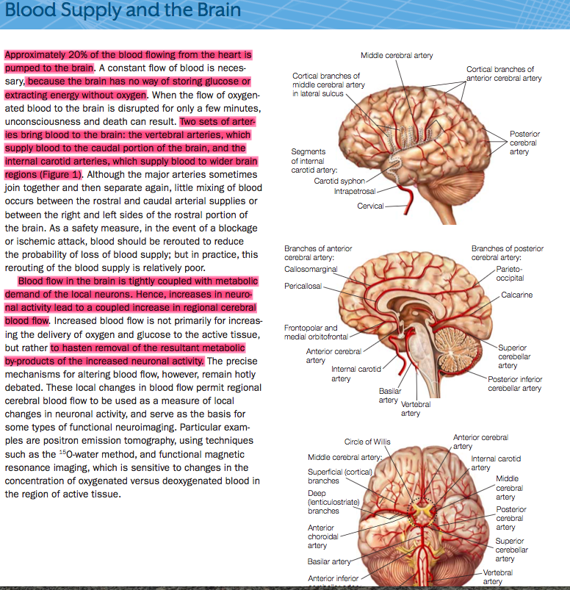

-----

draw a brain and use cool terms, (Dorsal, ventral, caudal, rostral) (

Explain this stuff:

small-world architecture - Brodman

Divitions in the brain

Broadmans - nissl stain

dienchepahlon and neocortex etc.

4 lobes

Often focus on neocortex and ignoring the brain stem etc. → dividing into four lobes, two hemisphere

Different areas - different functions →

* frontal lobes = planning

We look at BOLD response

-----

# Reading 3 - Methods of Cognitive Neuroscience with focus on fMRI

Literature: Gazzaniga et al p. 70-119 + Amaro and Barker 2006

THE SCIENTIFIC METHOD

Neuroscience and its scientist use the scientific method.

The process:

* Begins with an **observation** of a phenomenon

· The scientist devises **a hypothesis** to explain an observation and makes predictions drawn from the hypothesis.

· Designing **experiments** to test the hypothesis and its predictions.

· Such experiments employ the various methods

· Experiments within brain sciences cannot prove that a hypothesis is true

o They can provide support for a hypothesis or be used to disprove a hypothesis

Studying damaged brain: approach in the beginning → study the function of that damage area

* Broca’s patient ‘Tan’ → the idea of specific areas for specific functions
* Epileptic patients → split-brain research
* Prosopagnosia

Methods to study structure of brain:

* **Computed tomography (CT or CAT)** uses X-rays to image the 3-D structure of the brain.
* **Magnetic resonance imaging (MRI)** exploits the magnetic properties of the organic tissue of the brain to image its structure (anatomy)
  + An MR-scanner consists of multiple magnets
    - The main magnet creates a strong stable magnetic field, which is always on.
      * 10000 stronger than the earths magnetic field
    - The gradient coils make the main field vary slightly for localisation purposes
      * The scanner vibrates, which is the source of the noise
    - Radio Frequency (RF) coils produce and send radio waves
    - Radio Frequency (RF) coils receive radio waves
  + The structural MRI relies on different types of tissue have different types of relaxation (the realignment of the molecules' spin to the magnetic field of the MR-scanner)
  + The spatial resolution of MRI is superior to CT.
* **Diffusion tensor imaging (DTI)**, performed with MR-scanners, is used to measure white matter pathways in the brain and thus can offer information about anatomical connectivity between regions
  + Water diffuse in all directions, if unhindered i.e. hydrophobic materials
  + In white matter, it can only diffuse along fiber traits

Methods to study function of brain:

* Single-cell recording: Allows recordings from individual neurons i.e. measures membrane potential.
  + Often used on animals due to invasiveness
* Multiunit recording: The activity of hundreds of cells can be recorded at the same time.
* Electroencephalography (EEG): Measures the electrical activity of the brain.
  + An event-related potential (ERP): A change in electrical activity that is time-locked to specific events based on averaging of experimental stimuli. (Good temporal resolution)
  + Electrocortogram (ECoG):Similar to an EEG, except that the electrodes are placed directly on the surface of the brain.
* Magnetoencephalography (MEG): measures the magnetic signals generated by the brain.
  + The electrical activity of neurons also produces small magnetic fields, which can be measured by sensitive magnetic detectors placed along the scalp.
  + MEG can be used in an event-related manner similar to ERPs, with similar temporal resolution. (The spatial resolution can be superior because magnetic signals are minimally distorted by organic tissue such as the brain or skull)

Function + structure = neuroimaging:

* PET
  + inject radioactive tracer → emit positron → meet electron → gamma radiation released → scanner pick up signal
    - assumption: increased blood flow around active tissue
    - Weakness: radioactive tracers, poor temporal resolution (wait for blood to “arrive/circulate”), VERY expensive
* fMRI
  + BOLD response - ratio between deoxygenated and oxygenated blood Activation of a brain area → the vessels to widen → more oxygenated blood→ less magnetic field disturbances → the spin of the water molecule synchronizes for a longer period of time → the signal wished measured stays for a longer period of time

----------

Draw temporal spatial resolution map and explain all of the different ones. Could we have used EEG (yes, but…)

We can’t use TMS, because fusiform is too deep in brain. We can use OFA. Talk about the electrodes put on epilepsy patient. Mention grandmother cell, when we measure single cell recording.

* EEG / MEG
  + Look at N170 (Face stimuli) + N250 (familiarity)
    - When potentials evoked by images of faces are compared to those elicited by other visual stimuli, the former show increased negativity 130-200 ms after stimulus presentation. This response is maximal over occipito-temporal electrode sites, which is consistent with a source located at the fusiform and inferior-temporal gyri, confirmed by electrocorticography.The N170 generally displays right-hemisphere lateralization and has been linked with the structural encoding of faces
* PET
  + Not possible to test her multiple times
* Lesion
  + Prosopagnosia
* Single-unit
  + Wauw that was a trip video → Hallucinate facial features
    - PPA → Hallucinate landscape areas

---------

# Reading 4 - Hemispheric Specialization

Literature: Gazzaniga et al p. 120-161

Our participant was left handed.

From Gazzaniga book:

The right hemisphere is also specialized for e ciently detecting upright faces and discriminating among similar faces (Gazzaniga & Smylie, 1983). e le hemisphere is not good at distinguishing among similar faces, but it is able to distinguish among dissimilar ones when it can tag the feature di erences with words (blond versus bru- ne e, big nose versus bu on nose). As for the recognition of familiar faces in general, the right hemisphere outperforms the le hemisphere in this task (Turk, 2002).

What about that most familiar of faces, one’s own? In one study, so ware was used to morph the face of one split brain patient J.W. in 10 % increments, into that of a familiar other, Mike (Figure 4.18). e faces were asked randomly to J.W.’s separated hemispheres. en that hemisphere was asked, in the rst condition, “Is that you?” and, in another condition, “Is that Mike?” A double dissociation was found (Figure 4.19). e le hemisphere was biased towards recognizing one’s own face, while the right hemisphere had a recognition bias for familiar others (Turk et al., 2002).

///

Quick overview of hemisphere → right and left

* connected by corpus callosum
  + - Genu (Anterior -> Higher order semantic information) - Body - Splenium (Tactile and sensory information) (Aren’t any clear boundaries or landmarks seperating them)
  + (homotopic (corresponding regions) and heterotopic (different regions))
  + Ipsilateral -> connections within the same hemisphere

Language being left-lateralized → “Tan”, Wernicke’s area → one of the most investigated hemispheric specializations → locating language = Wada-test

Investigating the effects of hemisphere → Split-brain research

* example with the left hemisphere explaining for the actions of the right (figure 4.28)

Motor areas → left handed = activation in the right (Steph is left handed!!!)

* Right hemisphere specialized in detecting upright faces and discriminating between similar faces → our results in the right hemisphere
  + Left can only do with words → blond vs. brunette + left is also better when it comes to dissimilar faces
    - Experiment with J.W and Mike (figure 4.18)
  + Right hemisphere more global - left hemisphere more local targets
    - Experiment with global H and F (figure 4.26)
* Adding a picture of Steph herself might cause activation in the left hemisphere → double dissociation → left biased towards recognizing one’s own face, while the right is more for familiar others (figure 4.19)

# Reading 5 - Sensation and Perception with a focus on audition

Literature: Gazzaniga et al p. 162-127

/////

Patient P.T → could not recognize his wife + inability to recognize objects

Senses to recognize:

* Auditions
* Vision

Difference between sensation and perception:

* sensation can be intact, but have a percept deficit (prosopagnosia → they have working senses, but it is a perceptive deficit)
  + McGurk effect → perception of speech influenced by lip movements//

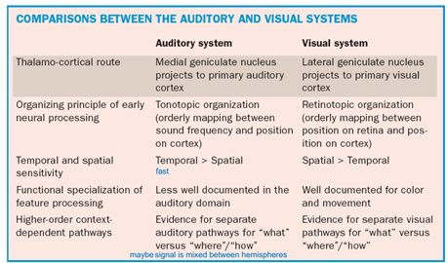

* Summary about audition and vision in the summary document

# Reading 6 - Object recognition with a focus on faces and words

Literature: Gazzaniga et al p. 218-271 + Dehaene & Cohen 2011

///

* Gnostic units = Grandmother cell
* STS = emotional face
* FFA = faces produce activation in this region of the brain → might fit with our findings
* Holistic vs. analysis-by-parts
  + Faces = holistic (figure 6.34)
* Agnosias = deficits in recognition or failure of knowledge
  + Prosopagnosia without visual agnosia = patient W.J (sheeps not family)
  + Visual agnosia without prosopagnosia = C.K recognise faces not objects (figure 6.32)
* Vegetable face painting
* Object constancy
  + View dependent theory: Template matching
  + View Invariant theory: FFA activation does not depend on the angle of your viewpoint. As long as all features are visible, activation won’t change.
  + Ocluded face renders less FFA activity

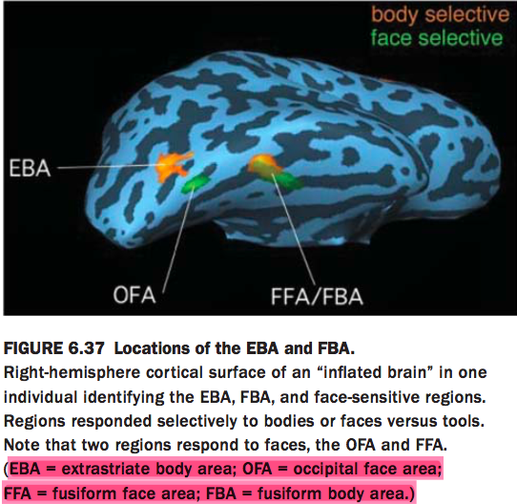

**The results showed a neat triple dissociation (Figure 6.38b–d). When TMS was applied over the rOFA, participants had problems dis-criminating faces, but not objects or bodies. When it was applied over the rEBA, the result was impaired discrimination of bodies, but not faces or objects. Fi- nally, as you have probably guessed, when TMS was applied over the rLO, the participants had difficulty picking out objects, but not faces or bodies (Pitcher et al., 2009). The latter result is especially interest- ing because the perception of faces and bodies was not disrupted**

* **The difference between EBA and FBA is their analytical and hollistic nature**
  + [**https://www.ncbi.nlm.nih.gov/pubmed/17596425**](https://www.ncbi.nlm.nih.gov/pubmed/17596425)
  + **Specifically, we hypothesize that the EBA analyzes bodies at the level of parts (as has been proposed for faces in the OFA), whereas FBA (by analogy to FFA) may have a role in processing the configuration of body parts into wholes.**

# Reading 7 - Action and the motor system

Literature: Gazzaniga et al p. 326-377 + Penfield & Rasmussen 1950 p. 11-66

///

* Important for survival → fight or flight
* Button press → simple movement → left-handed participant → right motor cortex activation

Anatomy of motor cortex:

* Hierarchical structure
* simple reflex movements without the brain
* planning more sophisticated movements → require more of the frontal
* somatosensory → homonculus
  + fusiform face area also said to be divided → faces, bodies, areas
* mirror neurons → our comprehension of actions involves our own involvement in those actions →
  + when you see someone playing basket, and you are a good player yourself than your mirror neurons will react more strongly → expertise related (Model 8.29 and 8.30)
  + Critique:
    - • Action execution and action understanding dissociate in humans
    - • Damage to the hypothesized human mirror system does not cause action understanding deficits.

**Is doing nothing an action? (Lying still in the scanner)**

Given that the world/time is never stable, doing nothing is actually a fairly complex task...

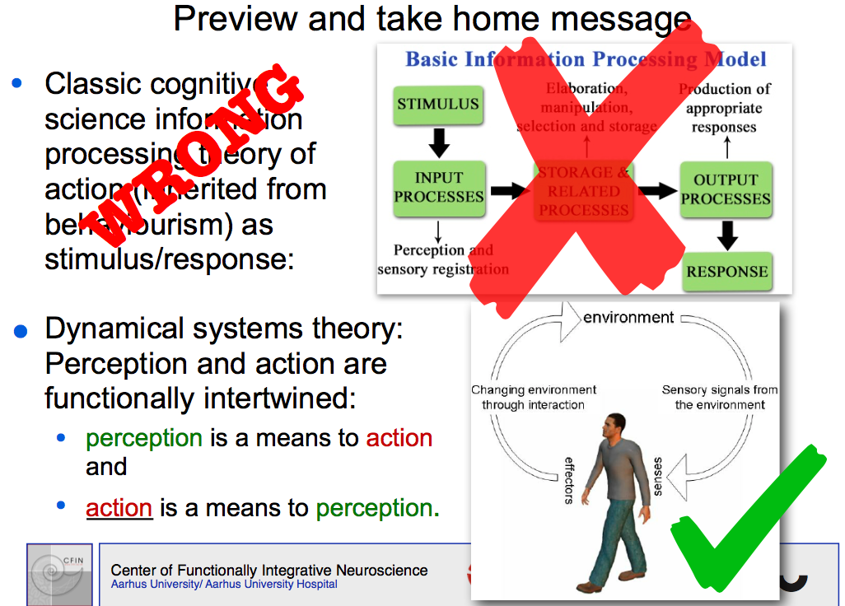

**Perception-action coupling**

Continuity between the different aspects of motor cognition can be traced to William James and Roger Sperry. Sperry argued that the perception–action cycle is the fundamental logic of the nervous system.

Perception and action are functionally intertwined:

* perception is a means to action and
* action is a means to perception.

The vertebrate brain has evolved for governing motor activity with the basic function to transform sensory patterns into patterns of motor coordination.

# Reading 8 - EEG and ERP with a focus on language

Literature: Gazzaniga et al p. 95-103, 491-500 + Luck 2014 + Näätänen et al. 1997

///

* What does EEG measure?
  + The sum of excitatory postsynaptic potentials
  + The pyramidal cells = aligned at the outer cortex
  + The problem is that fMRI etc. can only pick up on metabolic synchrony - That’s why we need EEG
* Difference between ERP and EEG
  + Event-related potentials
    - If two neurons are firing in the same pattern, they’re probably coding for the same
    - Alpha Wave - resting rhythm
* similarities between EEG and fMRI
  + Both non-invasive

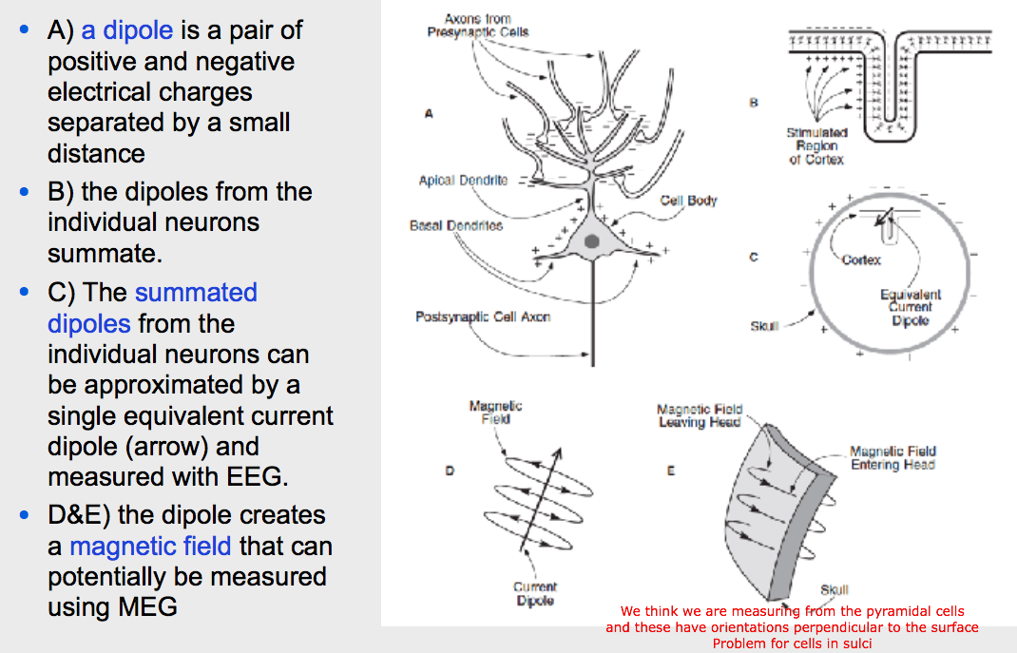

No real difference between a positive and a negative dipole (It’s just one or the other direction)

* differences between EEG and fMRI
  + fMRI better spatial resolution
  + EEG better temporal resolution
  + EEG “easy”, transportable // fMRI expensive and requires a set up
  + EEG measures electrical currents // fMRI measures BOLD response
* Could we have done with EEG?
  + N170 (face stimuli) not FFA (the poor spatial resolution)
  + The time-line of the processes (the great temporal resolution)
  + N250 (familiarity - maybe??????? FUCKING UNCERTAIN FIELD WE STUDY.......)

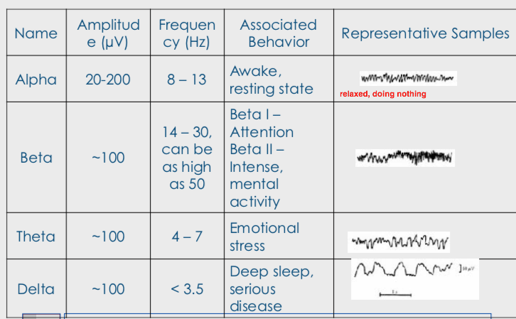

# Reading 9 - Memory

Different memory systems (figure 9.2)

* Independent of each other -> H.M
  + - * Intact STM (moderately)
      * Inability to transfer to LTM
* Famous cartoons + humans stored in long term memory (declarative) → semantic memory (objective knowledge)

Importance of memory:

* Remembering what things to avoid or approach
* Learning → the outcome of memory is learning (a memory is created when something is learned → some only stored briefly others for a long time)

Anatomy of memory

* Hippocampus, entorhinal cortex, perirhinal cortex, parahippocampal, medial prefrontal, medial temporal lobe.

Cellular basis of Learning and Memory:

* Memory is the result of changes in strength of synaptic interactions among neurons
* Long-Term-Potentiation → neurotransmitter glutamate → two receptors AMPA and NMDA (figure 9.39 + 9.40)
  + NMDA blocked by magnesium → cell depolarized → Mg ejected → Ca+ influx to postsynaptic cell → synaptic strength

Recollection and familiarity

* Different regions of the medial Temporal Lobe are responsible for encoding processes that identify an item as being familiar and correctly identify the item as having been seen before (recollection)
* Perirhinal cortex is sufficient to recognize something that is familiar (not fully recollected) → activation correlates with strength of familiarity
  + Regions of the left anterior medial parahippocampal gyrus - in and around the perirhinal cortex - activated during recognition based on familiarity
* Double dissociation in the medial temporal lobe for encoding memories:
  + One medial temporal lobe mechanism for recollection of episodic information
  + Another for supporting familiarity-based recognition in the perirhinal cortex

Deficits in the brain:

* Amnesia → Patient H.M no new long term memories → no other cognitive deficits
  + Anterograde: loss of memory from events after lesion → inability to learn new
  + Retrograde: loss of memory from events before lesion
    - Possibly due well on digit span tests
* Prosopagnosia → usually associated with damage to the fusiform gyrus

# 

# Reading 9.1 - Emotion

Literature: Gazzaniga et al p. 378-467

Anatomy of emotions → no single brain area is responsible for all emotions

We tried to pin down emotions, but look how that went:

**Neural systems**

▪ The Papez circuit describes the brain areas that James Papez believed were involved in emotion. They include the hypothalamus, anterior thalamus, cingulate gyrus, and hippocampus. Later, MacLean included the amygdala and the orbitofrontal cortex. The limbic system includes these structures and the amygdala, orbitofrontal cortex, and portions of the basal ganglia.

▪ Investigators no longer think there is only one neural circuit of emotion. Rather, depending on the emotional task or situation, we can expect different neural systems to be involved.

FFa is just recognition (presumably not affected by emotions), but if we include the STS (superior temporal sulcus).

Categorization of emotions

* basic emotions
* Complex
* Dimensions of emotions
  + Cartoon faces are usually smiling - does that play a role?
    - The beast wasn’t
    - https://www.ncbi.nlm.nih.gov/pmc/articles/PMC3809557/

Memories stored with a somatic marker → Putin , Mickey Mouse

Emotions related to the pictures → putin = disgust, angelina = jealousy

* characters all cause enjoy → these visual effects (animation and bright colours) might all relate to the memories by famous characters and thereby not as a big difference between fame related to characters → the features of characters all cause joy

Conveying emotional states to others → facial expressions

* Difference between emotional *experience* and *expression*

Race and emotional activation:

* Amygdala activation when white people view unfamiliar black faces, but not familiar black faces such as Michael Jordan
  + Our experiment contains pictures of both black and white faces + the aspect of familiarity → might be possible to spot an activation in the amygdala

# 

# Reading 10 - Language

Literature: Gazzaniga et al p. 468-505

//

H.W → left hemisphere stroke + right side hemisphre muscle weakness

Anatomy of language: perisylvian brain regions

**Left lateralized**

Split brain patients (and lesions) = Most studied and profound lateralization --> Left hemisphere --> does the lion’s share. Right --> prosody and rhythm, metaphorical meaning.

Experiment related to figure 11.15 → Visual Word Form Area and FFA → specialized modules

Like our study with faces, language is a huge “nature//nurture” debate.

Category specificity → living vs. nonliving

* FFA is also category specific

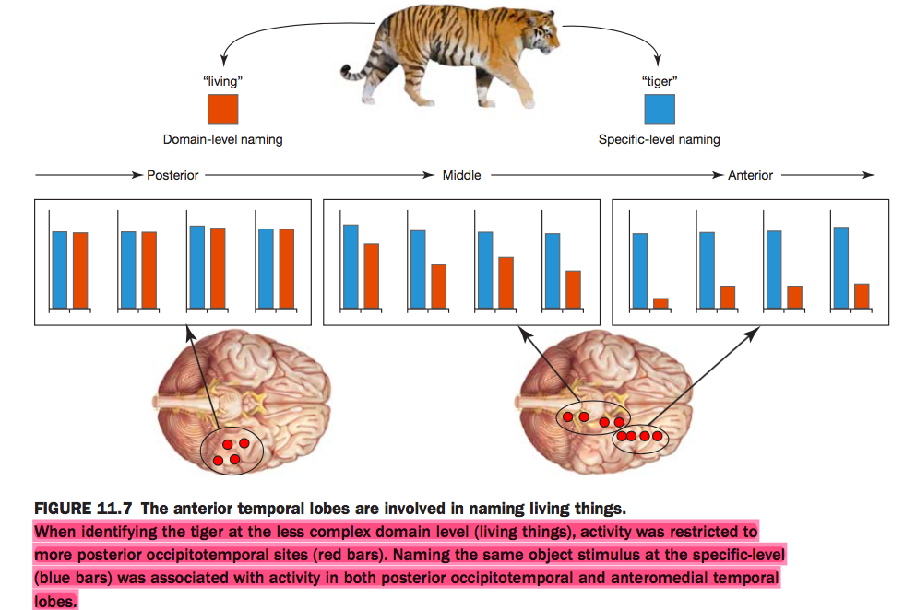



**The results showed a neat triple dissociation (Figure 6.38b–d). When TMS was applied over the rOFA, participants had problems dis-criminating faces, but not objects or bodies. When it was applied over the rEBA, the result was impaired discrimination of bodies, but not faces or objects. Fi- nally, as you have probably guessed, when TMS was applied over the rLO, the participants had difficulty picking out objects, but not faces or bodies (Pitcher et al., 2009). The latter result is especially interest- ing because the perception of faces and bodies was not disrupted**

* **The difference between EBA and FBA is their analytical and hollistic nature**
  + [**https://www.ncbi.nlm.nih.gov/pubmed/17596425**](https://www.ncbi.nlm.nih.gov/pubmed/17596425)
  + **Specifically, we hypothesize that the EBA analyzes bodies at the level of parts (as has been proposed for faces in the OFA), whereas FBA (by analogy to FFA) may have a role in processing the configuration of body parts into wholes.**